Student’s name | …………………………………………………….…… | Grade | 6
Subject | Computer | Week No. | 15
Lesson Title | Basic Electronics | Unit
Worksheet No. ( 15 ) (Answer)

Question A: write the correct name of each part.

Flow of electrons | Cat | Flow of electric current

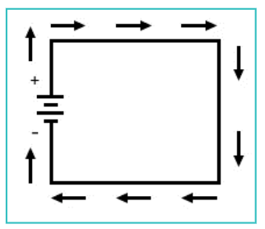
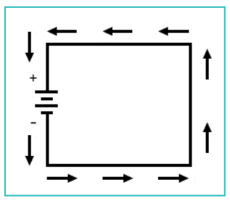
Flow of electrons
Flow of electric current
Good Luck

